Name

Mathematics Advanced Year 11
Exponential Functions

Book 1 |  | Version: 261020  Feedback:  https://MrDingMaths.com
Contents
Syllabus Content 2
Properties of the Exponential Curve 3
Exponential Curve Transformations 6
The Natural Exponential $e$ 13

Syllabus Content
MAV-11-08 analyses graphs of exponential and logarithmic functions
Exponential functions
- Graph the exponential functions $y=k\left(a^{x}\right)$ and $y=k\left(a^{-x}\right)$ for constants $a$ and $k$ where $a>0$, $a≠1$ and $k≠0$, and identify its asymptote, $y$-intercept, domain and range
- Describe the behaviour of $y=k\left(a^{x}\right)$ and $y=k\left(a^{-x}\right)$ as $x→∞$ and $x→-∞$
- Examine the gradient of the tangent to the curve $y=a^{x}$ at its $y$-intercept for varying values of $a$, and verify using graphing applications that there is a unique number $e≈2.71828182845$..., such that the gradient of the tangent to $y=e^{x}$ at $x=0$ is 1, and call this number $e$ Euler’s number
- Examine the gradient function of $y=a^{x}$ with graphing applications and identify that the gradient function is $\frac{d}{dx}\left(a^{x}\right)=ka^{x}$, for some constant $k$ depending only on $a$
- Conclude that Euler’s number, $e$, is a unique number such that $\frac{d}{dx}\left(e^{x}\right)=e^{x}$, that is, $e^{x}$ is its own derivative

Properties of the Exponential Curve

- Exponential Curves
An exponential relationship $y=a^{x}$ produces exponential curve graphs.
Exponential curves have these features:
- An asymptote: a line the graph approaches but never reaches.
- The nature of the graph (growth or decay) depends on the sign of $x$.
- Consecutive $y$ values change by a common ratio, which is the base number $a$.
$$y=a^{x}, a>1$$  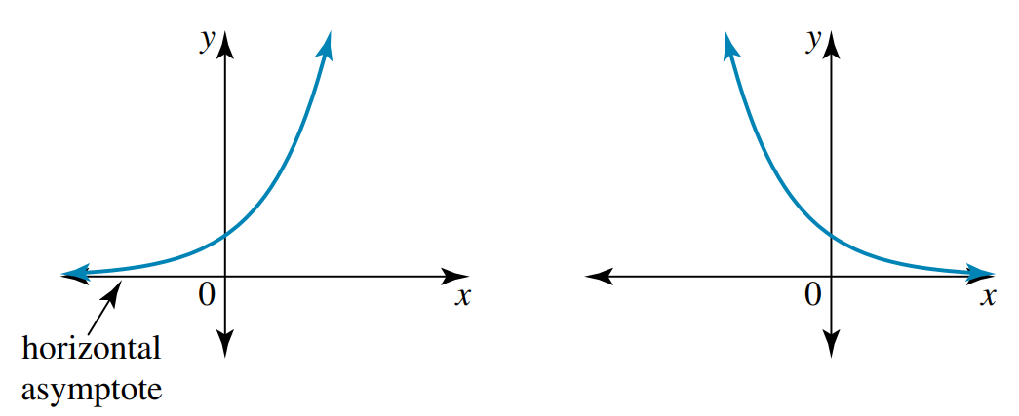  Increasing, exponential growth | $$y=a^{-x}, a>1$$  Decreasing, exponential decay

- Identify key features of an exponential curve
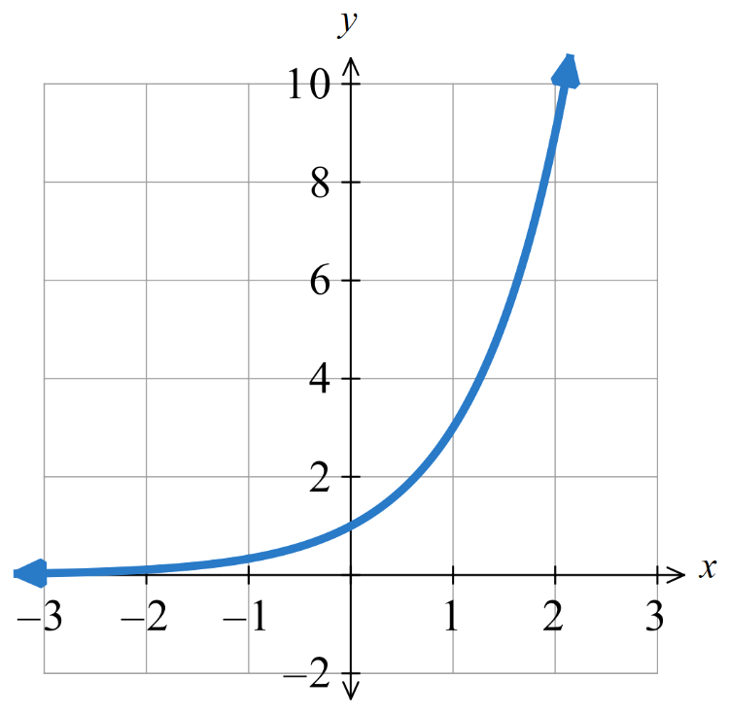  $y-$ intercept:  Asymptote:  Nature:  What happens to $y$ when $x→∞?$  What happens to $y$ when $x→-∞?$ | 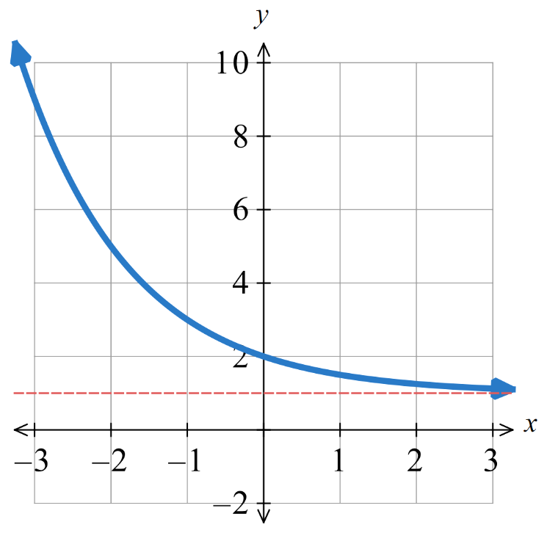  $y-$ intercept:  Asymptote:  Nature:  What happens to $y$ when $x→∞?$  What happens to $y$ when $x→-∞?$

Foundation
- Consider these exponential curves.
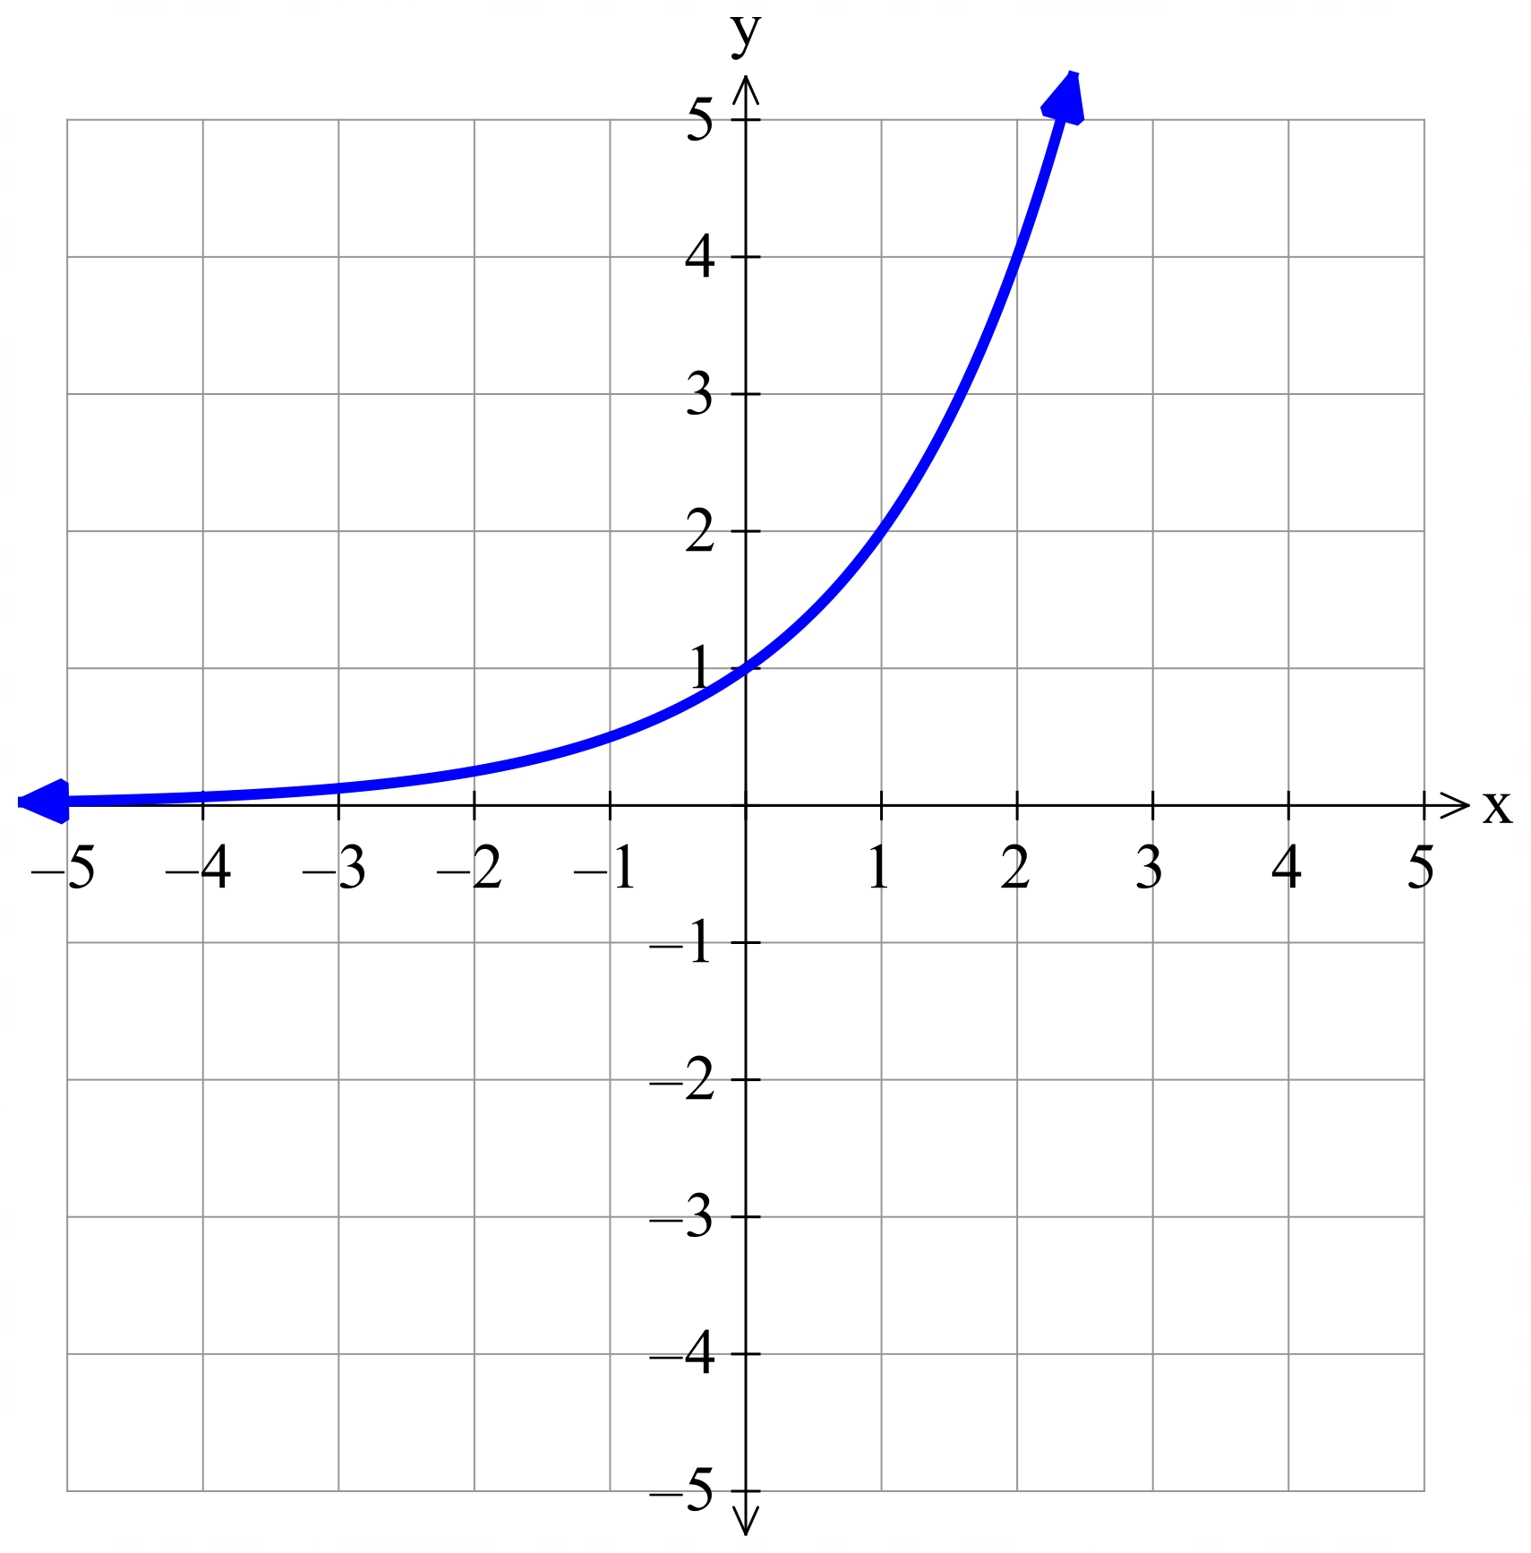  - $y=2^{x}$  $y$-intercept:  $$\left(0,1\right)$$  Asymptote:  $$y=0$$  Nature:  Increasing; exponential growth  What happens when $x→∞?$  $$y→∞$$  What happens when $x→-∞?$  $$y→0$$ | 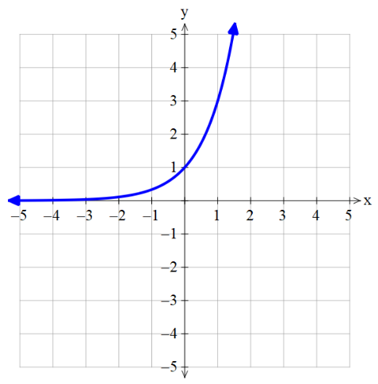  - $y=3^{x}$  $y$-intercept:  $$\left(0,1\right)$$  Asymptote:  $$y=0$$  Nature:  Increasing; exponential growth  What happens when $x→∞?$  $$y→∞$$  What happens when $x→-∞?$  $$y→0$$
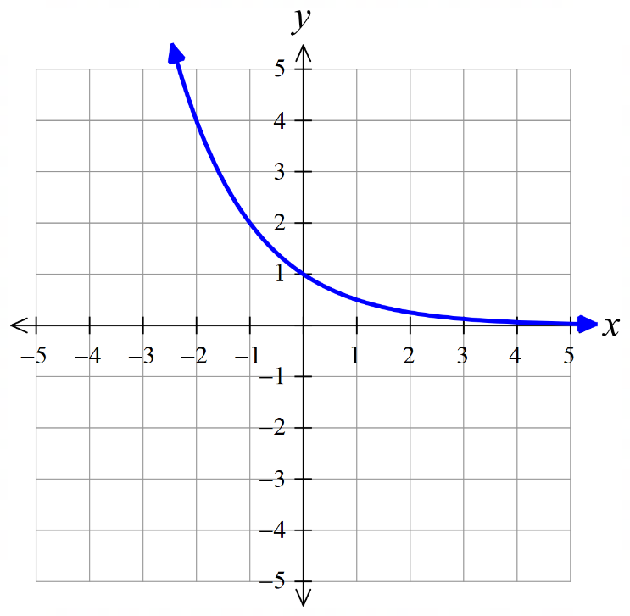  - $y={\left(\frac{1}{2}\right)}^{x}$  $y$-intercept:  $$\left(0,1\right)$$  Asymptote:  $$y=0$$  Nature:  decreasing; exponential decay  What happens when $x→∞?$  $$y→0$$  What happens when $x→-∞?$  $$y→∞$$ | - $y=2^{-x}$  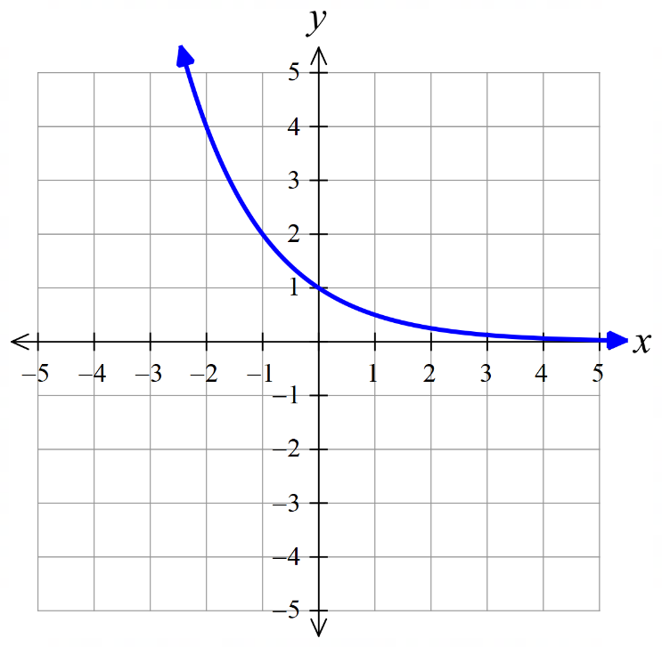  $y$-intercept:  $$\left(0,1\right)$$  Asymptote:  $$y=0$$  Nature:  decreasing; exponential decay  What happens when $x→∞?$  $$y→0$$  What happens when $x→-∞?$  $$y→∞$$

- What do you notice about part c and d above?
………………………………………………………………………………………………………………
They are the same.
- Consider these exponential curves.
- $y=-2^{x}$  $y$-intercept:  $$\left(0,-1\right)$$  Asymptote:  $$y=0$$  What happens when $x→∞?$  $$y→-∞$$  What happens when $x→-∞?$  $$y→0$$ | 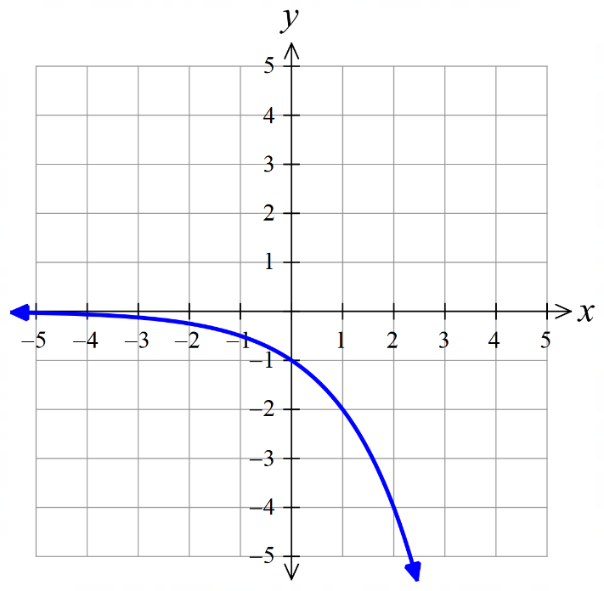  - $y=2^{x}+3$  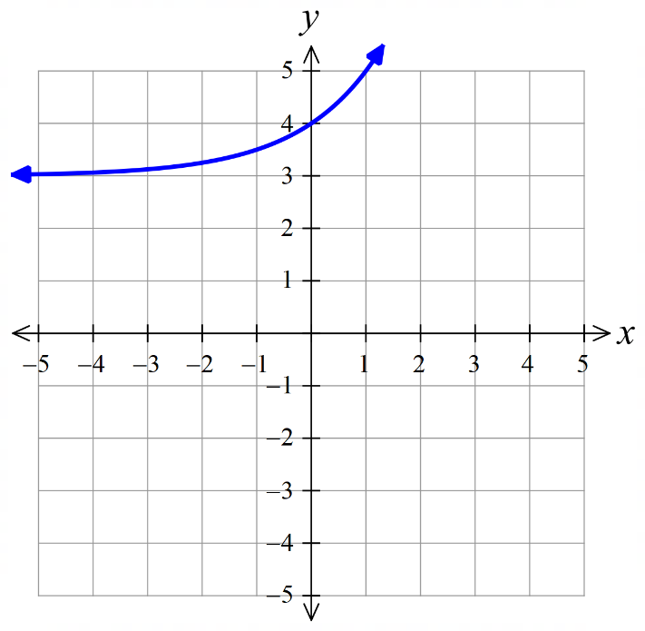  $y$-intercept:  $$\left(0,4\right)$$  Asymptote:  $$y=3$$  What happens when $x→∞?$  $$y→∞$$  What happens when $x→-∞?$  $$y→3$$
- $y=-2^{x}+3$  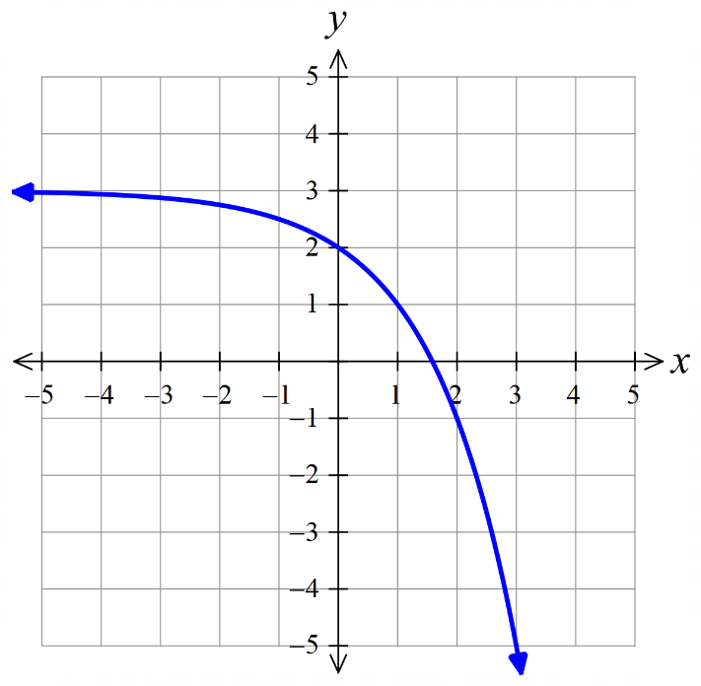  $y$-intercept:  $$\left(0,2\right)$$  Asymptote:  $$y=3$$  What happens when $x→∞?$  $$y→-∞$$  What happens when $x→-∞?$  $$y→3$$ | - $y={\left(\frac{1}{3}\right)}^{x}-2$  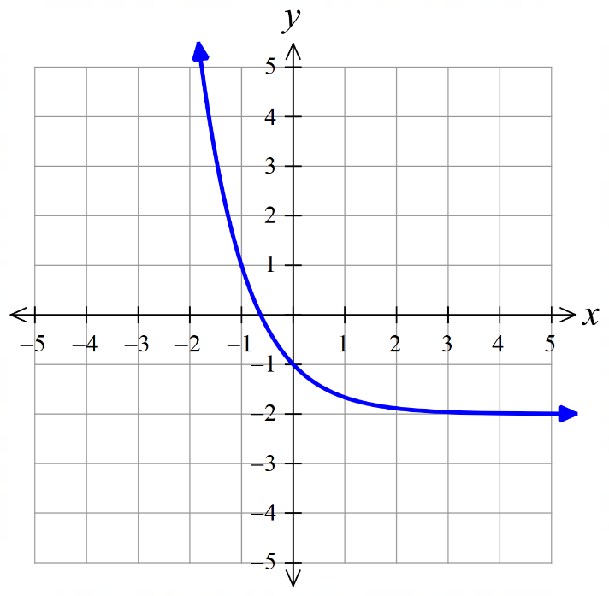  $y$-intercept:  $$\left(0,-1\right)$$  Asymptote:  $$y=-2$$  What happens when $x→∞?$  $$y→-2$$  What happens when $x→-∞?$  $$y→-∞$$

Exponential Curve Transformations

- Exponential Curve Transformations
$a>1$ exponential growth  $0<a<1$ exponential decay  Common ratio  $$y=k⋅a^{x}$$  Factor; affects $y$-intercept and reflects across $x$ axis if negative |  | $a>1$ exponential decay  $0<a<1$ exponential growth  Common ratio  $$y=k⋅a^{-x}$$
$$y=2^{x}$$ | $y=2^{-x}$ or $y={\left(\frac{1}{2}\right)}^{x}$  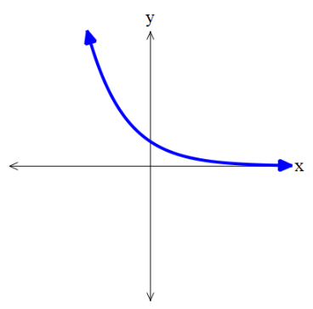 | $$y=-2^{x}$$  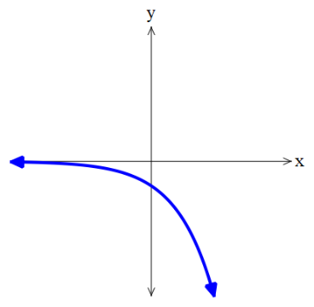  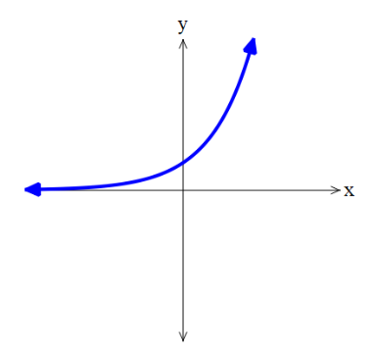 | $y=-2^{-x}$ or $y=-{\left(\frac{1}{2}\right)}^{x}$  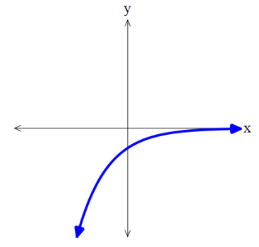

- Exponential Curve Transformations
Consider the equation of an exponential curve $y=k{(a)}^{x}+c$, where $a>0$
The parameters $a,c, k$ are numbers that affect the graph in predictable ways.
$a>1$, we call this exponential ………………  $$y=2^{x}$$ | $0<a<1$, we call this exponential …………  $$y={\left(\frac{1}{2}\right)}^{x}$$  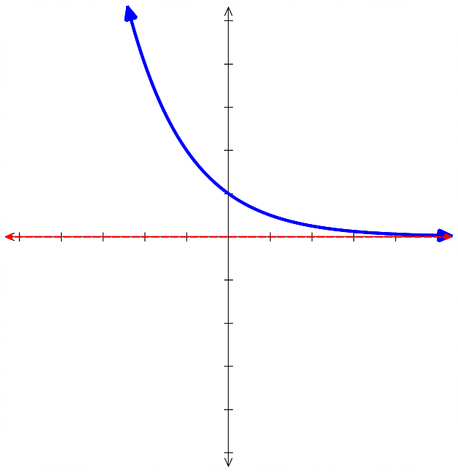  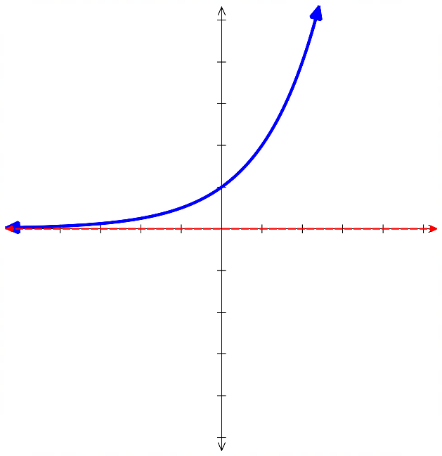
$c>0$, the curve is shifted ……………  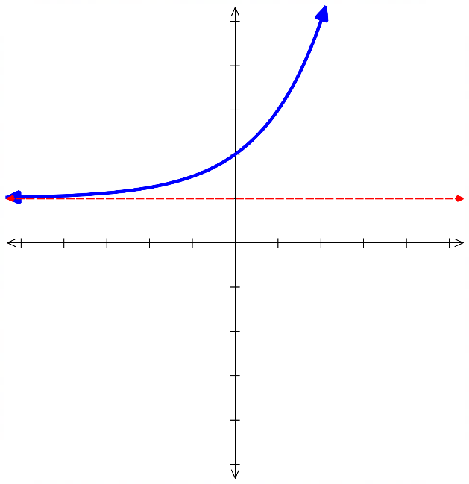  The value of $c$ is the ……………………  $$y=2^{x}+1$$ | $c<0$, the curve is shifted ……………  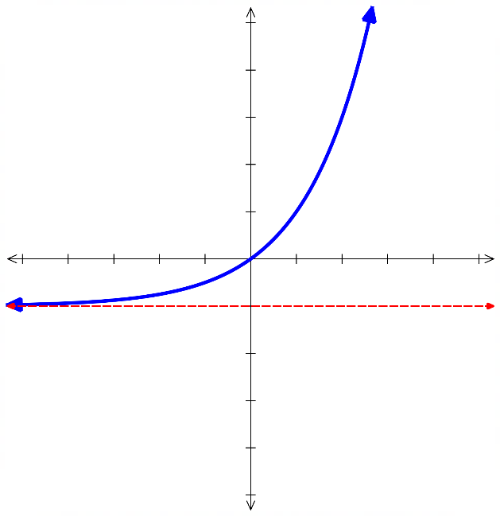  The value of $c$ is the ……………………  $$y=2^{x}-1$$
$k>0$  $$y=1\left(2^{x}\right)$$  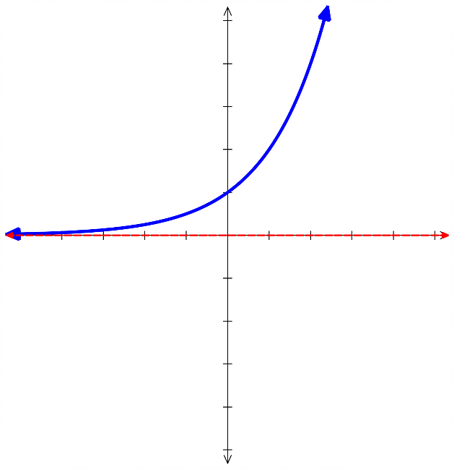 | $k<0$, reflect the graph across $x$-axis  $$y=-1 \left(2^{x}\right)$$  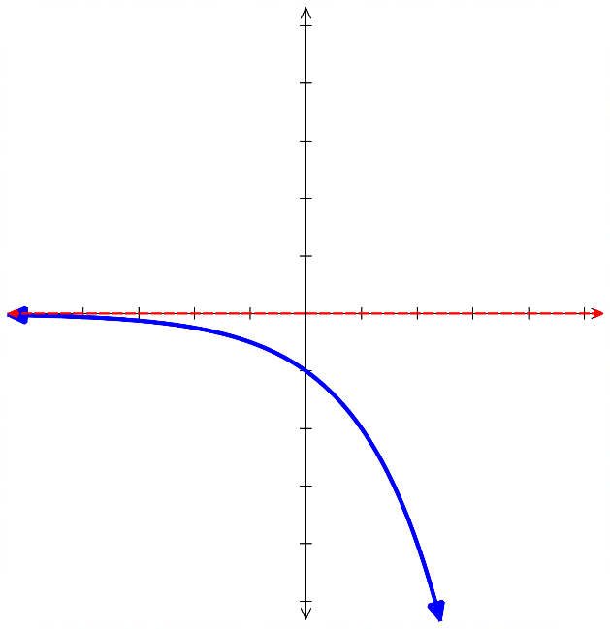
$\left|k\right|>1$, the curve changes more quickly.  $$y=3\left(2^{x}\right)$$  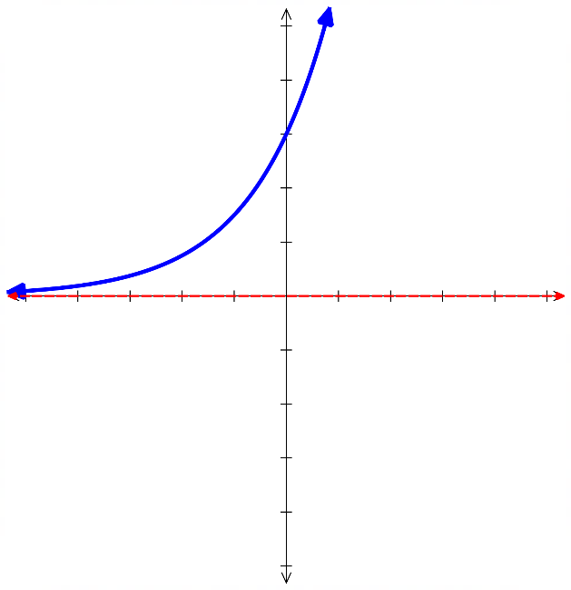 | $0<\left|k\right|<1$ the curve changes more slowly.  $$y=\frac{1}{3}\left(2^{x}\right)$$  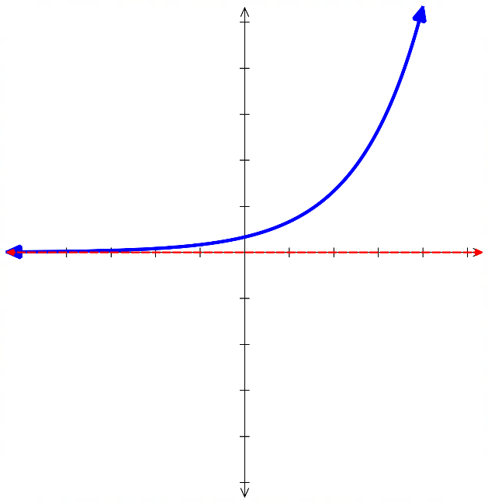

- Exponential Curve Transformations
$a>1$ exponential growth  $0<a<1$ exponential decay  Common ratio  $$y=k⋅a^{x}+c$$  Factor; affects $y$-intercept and vertical translation  reflects across $x$ axis if negative $y=c$ is asymptote | $a>1$ exponential decay  $0<a<1$ exponential growth  Common ratio  $$y=k⋅a^{-x}+c$$
To sketch exponential curves:
- Find $y$-intercept by letting $x=0$.
- Find asymptote: $y=c$.
- Plot at least one other point, such as at $x=1$.
- You do not need to find $x$-intercepts until you learn logarithms

- Example Sketch transformations of exponential curves
$y=2^{x}-4$  1. $y$-int: Let $x=0$,  $y=2^{0}-4=-3$  2. Asymptote: $y=-4$  3. When $x=1$: $y=2^{1}-4$  $y=-2$  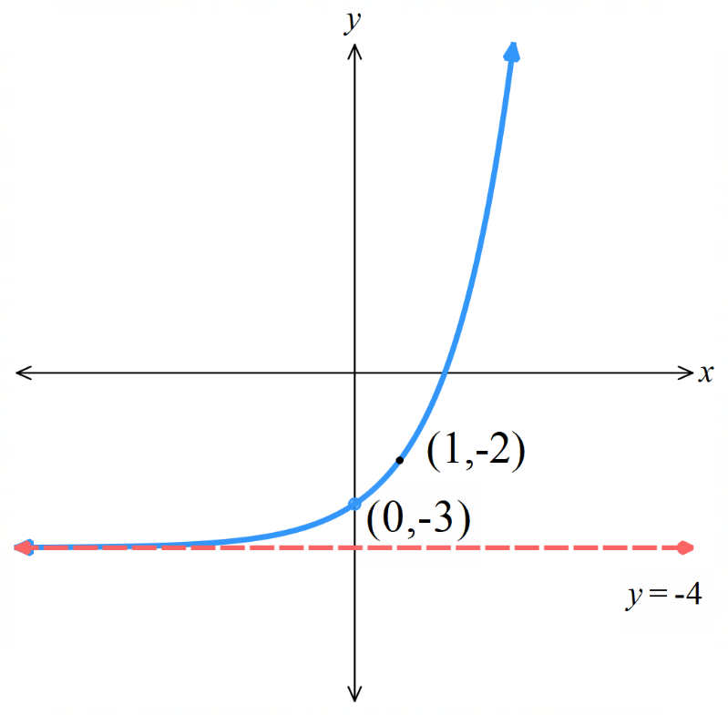  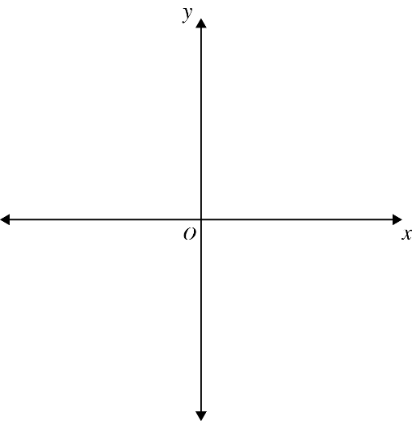 | $y=3^{-x}-5$  1. $y$-int:  2. Asymptote:  3. Another point:  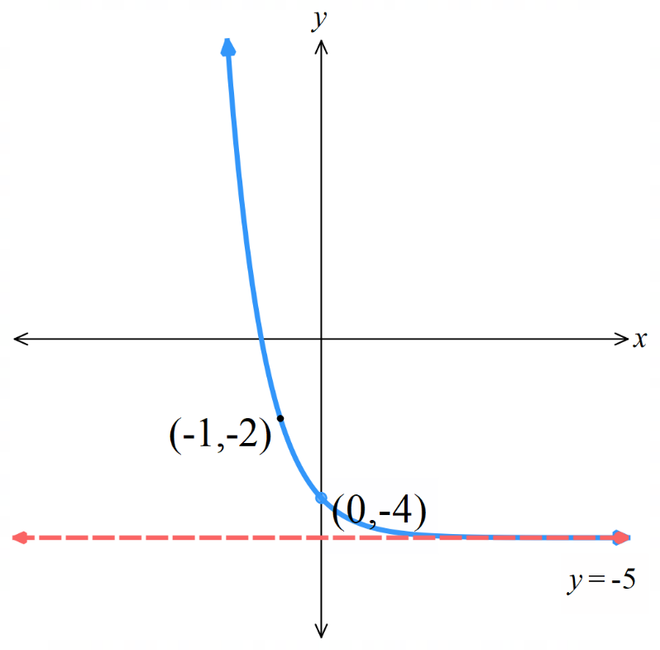

Foundation
- The graph of $y=2^{x}$ is given. Sketch these graphs on the same axis to show the transformation.
Clearly label the $y$-intercept, asymptote, and the point where $x=1$.
- $y=2^{x}+1$  $y$-int:  Asymptote:  When $x=1$:  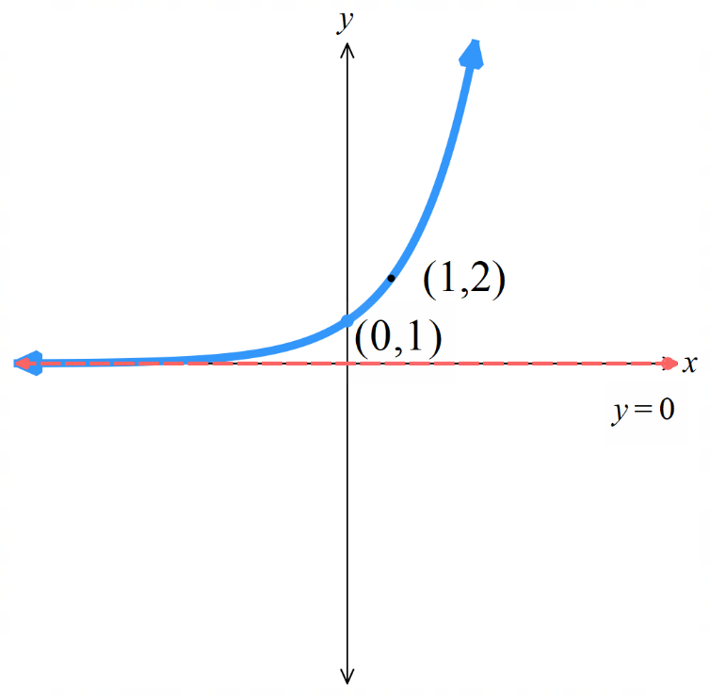 | - $y=2^{x}-3$  $y$-int:  Asymptote:  When $x=1$: | - $y=2^{x}-5$  $y$-int:  Asymptote:  When $x=1$:
- $y=3^{x}$  $y$-int:  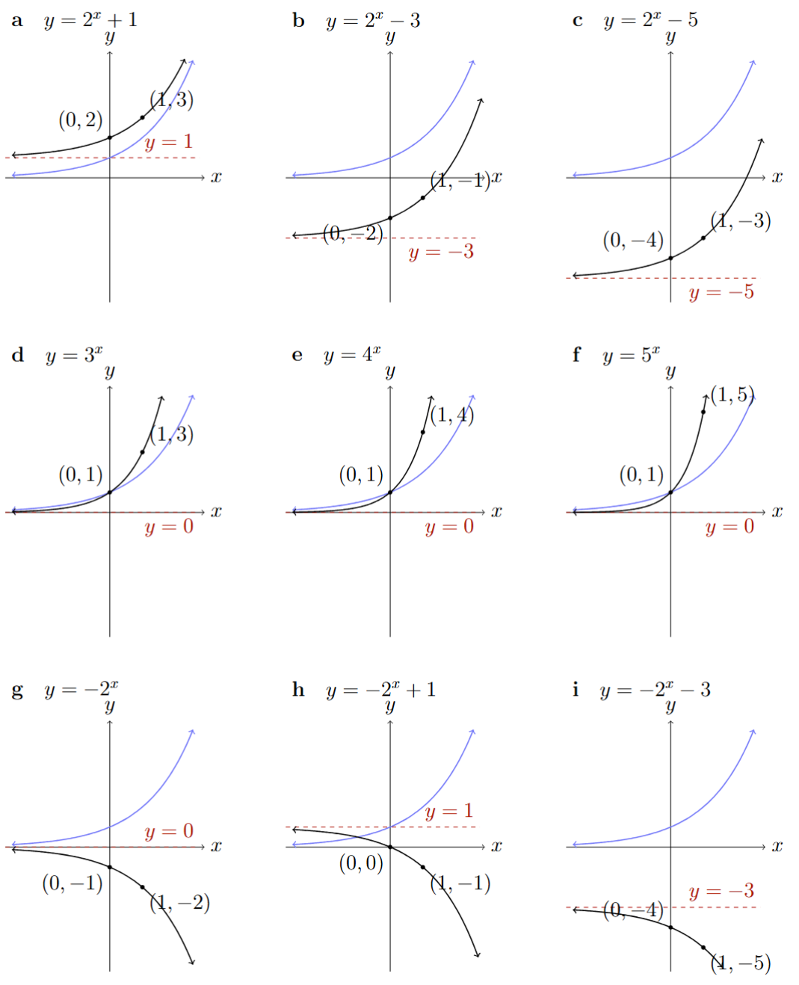  Asymptote:  When $x=1$: | - $y=4^{x}$  $y$-int:  Asymptote:  When $x=1$: | - $y=5^{x}$  $y$-int:  Asymptote:  When $x=1$:
- $y=-2^{x}$ | - $y=-2^{x}+1$ | - $y=-2^{x}-3$
- $y=3(2^{x})$ | - $y=-3(2^{x})$ | - $y=0.5(2^{x})$  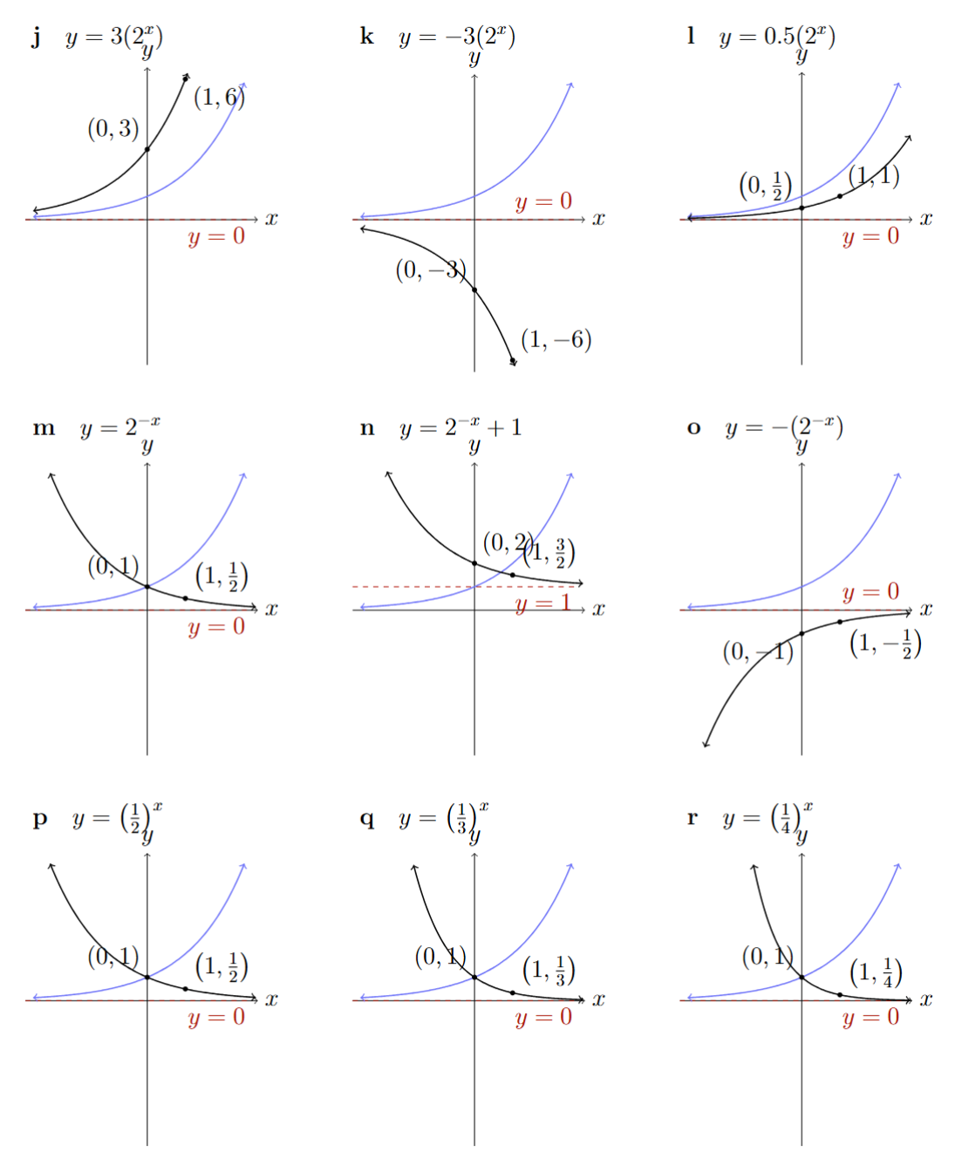
- $y=2^{-x}$ | - $y=2^{-x}+1$ | - $y=-{(2}^{-x})$
- $y={\left(\frac{1}{2}\right)}^{x}$ | - $y={\left(\frac{1}{3}\right)}^{x}$ | - $y={\left(\frac{1}{4}\right)}^{x}$

Development
- Sketch these exponential equations.
Clearly label the $y$-intercept, asymptote, and the point where $x=1$.
- $y=3^{x}+2$  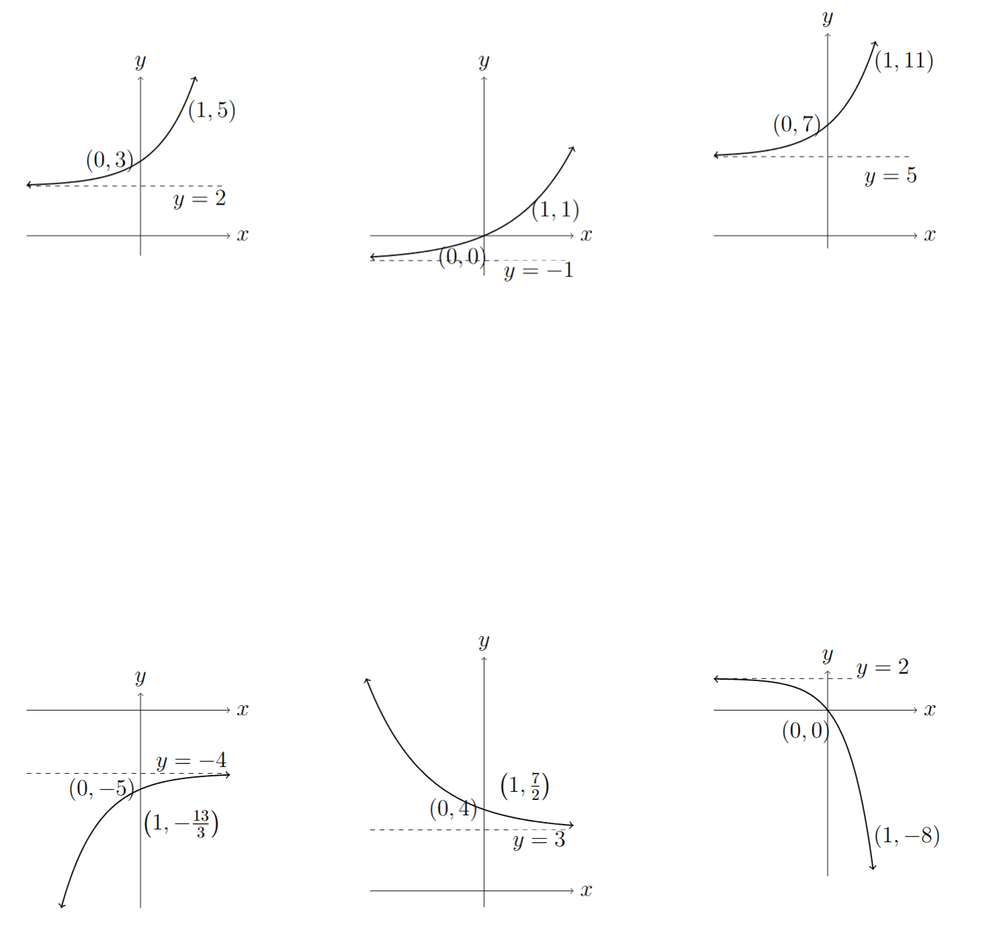 | - $y=2^{x}-1$ | - $y=2{(3}^{x})+5$
- $y=-3^{-x}-4$ | - $y=2^{-x}+3$ | - $y=-2\left(5^{x}\right)+2$

Mastery
- Match the equation to the graph.
$y=6^{x}$ $y=-6^{x}$ $y=-6^{x}-2$ $y=-6^{x}+2$ $y=6^{-x}$
$y=6^{-x}-2$ $y=6^{-x}+2$ $y=-6^{-x}$ $y=-6^{-x}-2$ $y=6^{-x}+2$

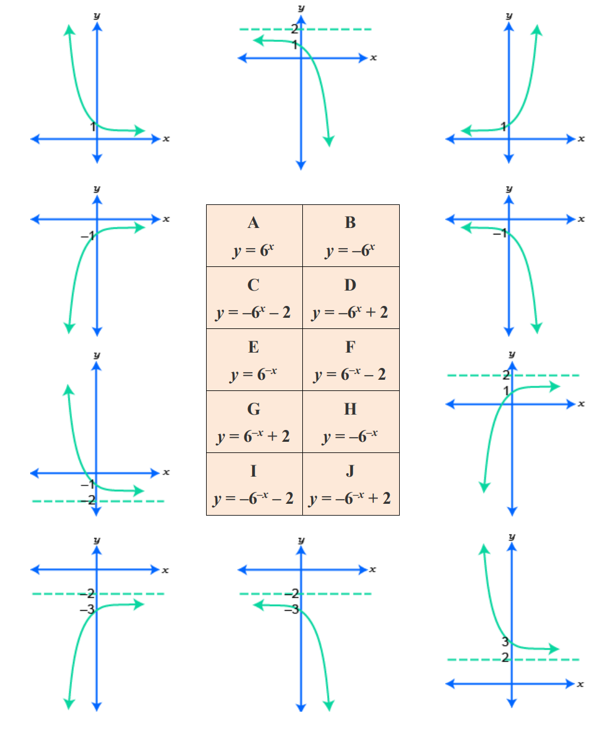  $$y=6^{-x}$$ | $$y=-6^{x}+2$$ | $$y=6^{x}$$ | $$y=-6^{-x}$$
$$y=-6^{x}$$ | $$y=6^{-x}-2$$ | $$y=-6^{-x}+2$$ | $$y=-6^{-x}-2$$
$$y=-6^{x}-2$$ | $$y=6^{-x}+2$$

The Natural Exponential $e$

- Investigation Euler’s number $e$
- Using Desmos:
- Sketch the function $f\left(x\right)=2^{x}$, then sketch $f^{'}\left(x\right)$ on the same axis.
What do you notice about the shape of the derivative function?

- Sketch the function $f\left(x\right)=4^{x}$, then sketch $f^{'}\left(x\right)$ on the same axis.
What do you notice about the shape of the derivative function?

- For $f\left(x\right)=a^{x}$, when $a=2,$ $f^{'}\left(x\right)$ is ………………… than the original function.
when $a=4,$ $f^{'}\left(x\right)$ is ………………… than the original function.
So, we can write the derivative of $\frac{d}{dx}\left(a^{x}\right)=$ …… $a^{x}$
So, there must be a value of $a$ such that $f\left(x\right)=f^{'}\left(x\right)$.

Use Desmos to sketch $f\left(x\right)=a^{x}$ and $f'(x)$.
Use the slider to find a value where the derivative function matches the original function. What value of $a$ is this?
$a=$ ………………

We call this number ……………’s number.
We call any exponentials in the form $f\left(x\right)=$ ………… “natural” exponentials.

- Natural Exponentials
Euler’s number $e=2.71828182845…$ has a unique property:
$$if f\left(x\right)=e^{x} \\ then f^{'}\left(x\right)=e^{x}$$
This means $f\left(x\right)=f^{'}\left(x\right)$, the function equals its own derivative.
The rate of growth stays proportional to the current amount.
This exponential relationship models many real-life phenomena, such as:
population growth, disease spread, radioactive decay, compound interest.

Foundation
- Using a calculator, evaluate to 3 s.f.
- $e^{2}$  $$7.39$$ | - $-\sqrt{e}$  $$-1.65$$ | - $\frac{1}{e^{3}}$  $$0.0498$$

- The mass of a radioactive substance in grams is given by $M=150e^{-0.014t}$ where $t$ is in years.
Find these masses. Round to 2 d.p. where appropriate.
- Initial mass  150 g | - Mass after 10 years  130.40 g | - Mass after 250 years  4.53 g
- What will the mass become as $t→∞$ years?

Approaches $0$g

- The population of koalas is currently increasing according to the formula $N=1250e^{0.25t}$, where $t$ is in months. Find these populations, rounding to the nearest koala.
- Initial population  1250 | - Population after 12 months  25 107 | - Population after 5 years  4 086 271 716
- Is this a realistic model for the population of koalas long-term?

No, exponential growth cannot continue forever.

- Consider the graph of $y=e^{x}$ shown below and its tangent line at $y=1$.
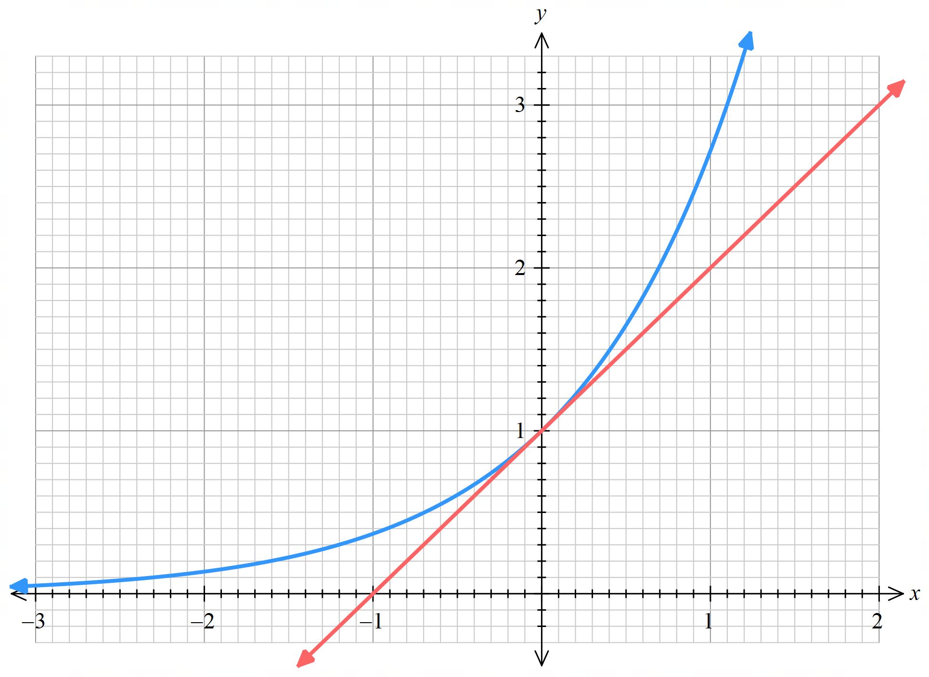

  - The tangent at $y=1$ is shown on the graph.
By inspecting the line, what is the gradient of the tangent at $y=1$?
1
  - By drawing additional tangent lines at $y=\frac{1}{2}, y=2, y=3,$ complete the table:
Function value $y$ | $$\frac{1}{2}$$ | $$1$$ | $$2$$ | $$3$$
Gradient $\frac{dy}{dx}$ | $$\frac{1}{2}$$ | 1 | $$2$$ | $$3$$

  - How is the gradient of the tangent related to the function value for $y=e^{x}$?
$$\frac{dy}{dx}=y$$
or, $f\left(x\right)=f^{'}\left(x\right)$
  - On the same graph as above, sketch tangent lines at $x=-1, x=0, x=1.$
What do you notice about the $x$-intercepts of the tangent lines?

The $x$ intercepts are always 1 unit to the left of the point of tangency.

